Debenham Neighbourhood Plan

Landscape Character Assessment – Natural Environment

Baseline Evaluation

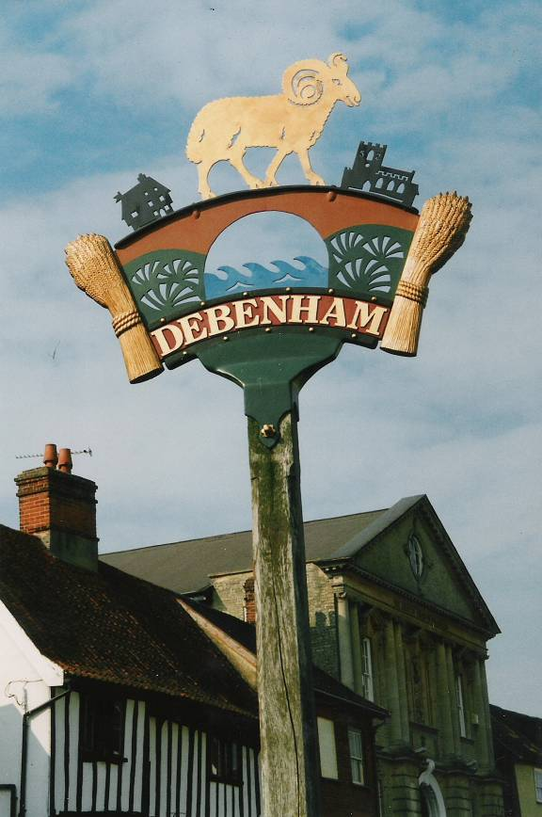

2016

Debenham Landscape Character Assessment – Natural Environment

The following constitutes the way in which the landscape character assessment in the Neighbourhood Plan has been developed.

Baseline Evaluation
Baseline conditions are defined by landscape character and respective sensitivity, together with visual amenity (as represented by views) and the sensitivity of visual receptors (or potential viewers), in accordance with the criteria set out below.
Definitions of landscape Sensitivity
Level of Sensitivity Definition of Sensitivity Examples
High Typically of high importance and rarity, national
scale and limited potential for substitution, (eg
National Parks or Areas of Outstanding Natural
Beauty). Landscape unlikely to tolerate significant
change.
Medium Typically of moderate importance and rarity,
Regional scale, and limited potential for substit-
ution, (eg Registered Historic Parks and Gardens
and Conservation Areas). Landscape likely to
tolerate some change.
Low Typically of low importance and rarity, local scale
such as undesignated or degraded landscapes.
Landscape has the potential to tolerate change.
Definitions of Visual Sensitivity
Level of Sensitivity Definition of Sensitivity Examples
High Views from important landscapes where apprecia-
tion of affected views may be the principal activity.
Residential properties.

Medium Views from Public Right of Ways, cycle trails, public
open space or regionally/ local important landscapes
where attention may be focused on an affected view.

Low Views from roads and railways which are transient
due to travelling through the landscape. Places of
work or commercial properties, where attention is
unlikely to be focused on affected views.

Assessment
The criteria and threshold matrices used to assess the magnitude of impact and significance of landscapes and visual effects are set out below.

Assigning Magnitude of Landscape Impact

Level of Magnitude Definition of Magnitude

High Total loss or major alteration to key landscape
characteristic such that the landscape character
will be fundamentally changed.

Medium Partial loss or alteration to key landscape charact-
eristic such that the landscape character will be
partially changed.

Low Minor loss or alteration to key landscape character-
istics such that the landscape character will be
similar to the baseline conditions.

Negligible Very minor loss or alteration to key landscape
characteristics such that change in the landscape
character will be barely distinguishable from the
baseline conditions, approximating to the ‘no -
change’ situation.

Assigning Magnitude of Visual Impact
Level of Magnitude Definition of Magnitude
High Major change in existing view.
Medium Partial change in existing view.
Low Minor change such that it is largely unchanged.
Negligible Very inconspicuous change approximating to
‘No – change’.

A combined assessment of sensitivity and magnitude is undertaken to determine how significant an effect is, as shown below.
Significance Matrix
Magnitude Sensitivity
Low Medium High

High Moderate Moderate/Major Major
Medium Minor/Moderate Moderate Moderate/Major
Low Minor Minor/Negligible Moderate
Negligible Negligible Negligible Negligible

Effects may be positive or negative. Applying the precautionary principle, this assessment identifies potential effects as negative although it should be noted that any development may not be regarded by all as having an adverse effect. Only those effects that are recorded as major negative are considered to be significant in respect of the decision making process (see italics and underline significances identified above.)
Base line
Landscape Designations
Defining the landscape character of an area will shape future development, and affect the setting in which people live and work in Mid Suffolk. The majority of the landscape of the Debenham Neighbourhood Plan area is classified as arable land. This is the same for the surrounding parishes. There are areas classified as grassland, most of which are connected to the suburban areas. There are areas of land classified as woodland in the parish area. The Debenham Neighbourhood Plan area features Grade 2 and 3 agricultural land. This means that the land is very good and good to moderate for agricultural use.
Government policy for England is set out in the National Planning Policy Framework (NPPF) published in March 2012 (paragraph 112). Decisions rest with the relevant planning authorities who should take into account the economic and other benefits of the best and most versatile agricultural land. Where significant development of agricultural land is demonstrated to be necessary, local planning authorities should seek to use areas of poorer quality land in preference to that of higher quality.
The Agricultural Land Classification system classifies land into five grades, with Grade 3 subdivided into sub- grades 3a and 3b. The best and most versatile land is defined as Grades 1, 2 and 3a by policy guidance (see Annex 2 of NPPF). This is the land which is most flexible, productive and efficient in response to inputs and which can best deliver future crops for food and non-food uses such as biomass, fibres and pharmaceuticals.

